**Report on Analysis of Covid – 19 Dataset**

**Bar graph of total cases vs highest covid cases –**

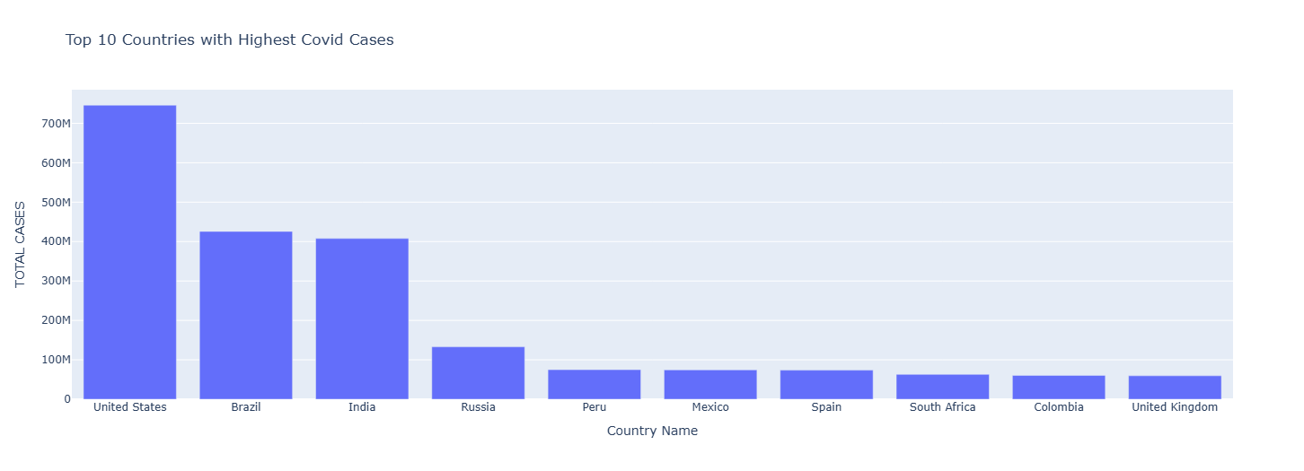

**Analysis –**

This graph is comparing the total number of COVID-19 cases for the top 10 countries with the highest number of cases.

* United States: Has the highest number of cases by a significant margin.
* Brazil and India: Have the second and third highest number of cases, respectively.
* Russia, Peru, Mexico, Spain, South Africa, Colombia, and United Kingdom: These countries have lower numbers of cases compared to the top three.

**COVID-19 Cases and Deaths in Top 10 Countries -**

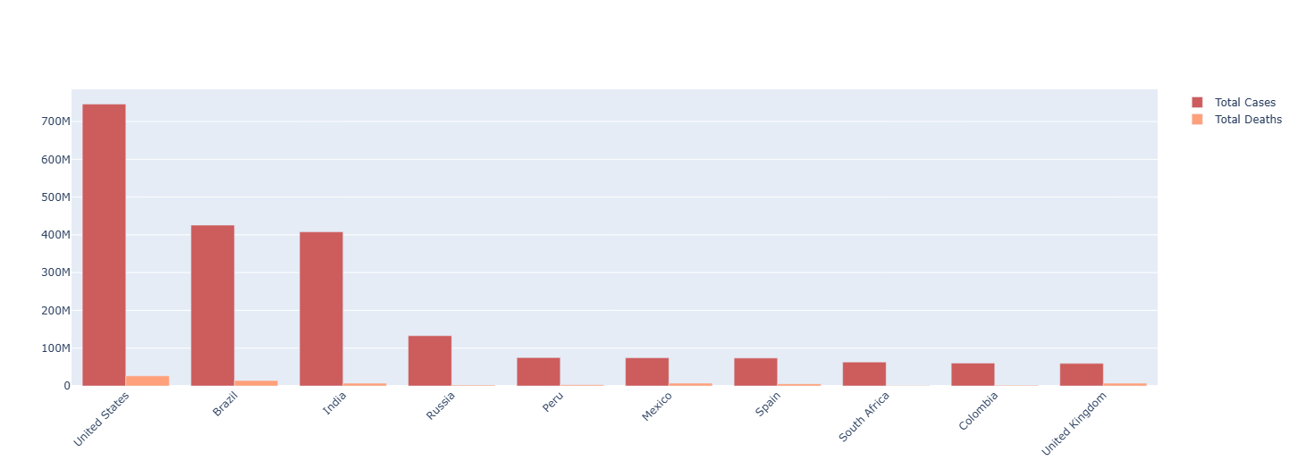

**Analysis –**

This graph compares the total number of confirmed COVID-19 cases and deaths for the top 10 countries with the highest number of cases.

* United States: Has the highest number of both cases and deaths.
* Brazil and India: Follow with the next highest number of cases and deaths.
* Russia, Peru, Mexico, Spain, South Africa, Colombia, and United Kingdom: These countries have lower numbers of cases and deaths compared to the top three.

**Bar graph of stringency index during covid-19 –**

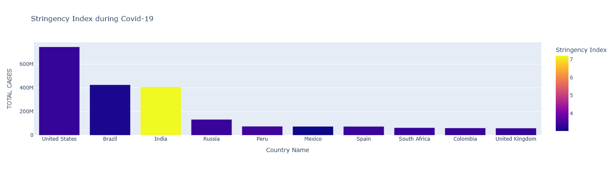

**Analysis –**

This graph is comparing total cases vs country name when stringency index during covid:

* **Total Cases of Covid-19:** The height of each bar represents the number of confirmed COVID-19 cases in that country.
* **Stringency Index:** The color of each bar shows the level of strictness of COVID-19 restrictions in that country. The color scale ranges from purple (less strict) to yellow (more strict).
* **United States, Brazil, and India:** These three countries have the highest number of COVID-19 cases.
* **United States:** Has the highest number of cases and a high stringency index.
* **India:** Has a high number of cases but a lower stringency index compared to the US.

**Bar graph of GDP before Covid -19**

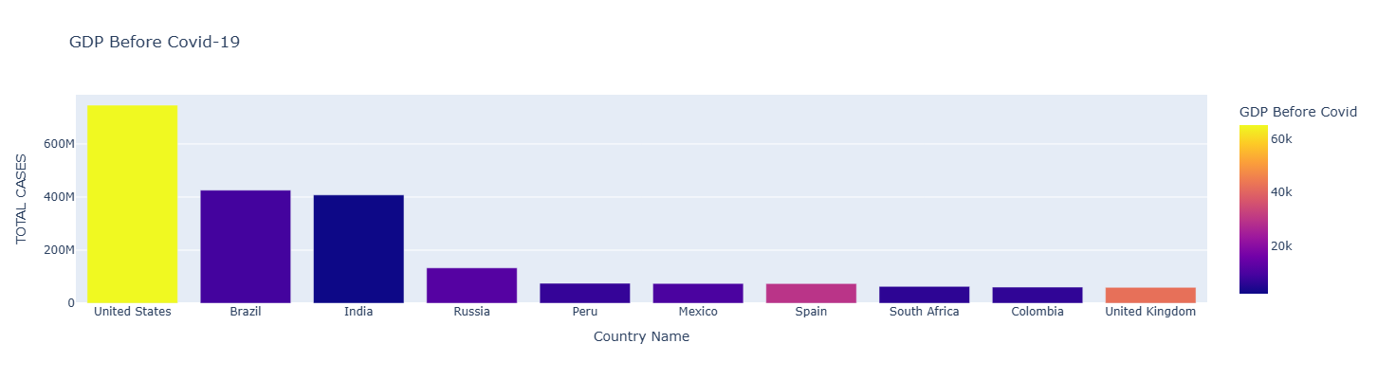

**Analysis –**

This graph is comparing total cases vs country name where GDP before covid 19:

1. **Total Cases of Covid-19:** The height of each bar represents the number of confirmed COVID-19 cases in that country.
2. **GDP Before Covid-19:** The color of each bar shows the GDP (Gross Domestic Product) of the country before the COVID-19 pandemic. The color scale ranges from purple (lower GDP) to yellow (higher GDP).
3. **United States:** Has the highest number of cases and the highest GDP.
4. **Brazil and India:** Have high numbers of cases and lower GDP compared to the US.
5. **Russia, Peru, Mexico, Spain, South Africa, Colombia, and United Kingdom:** These countries have lower numbers of cases and lower GDP.

**Bar graph of GDP during Covid -19**

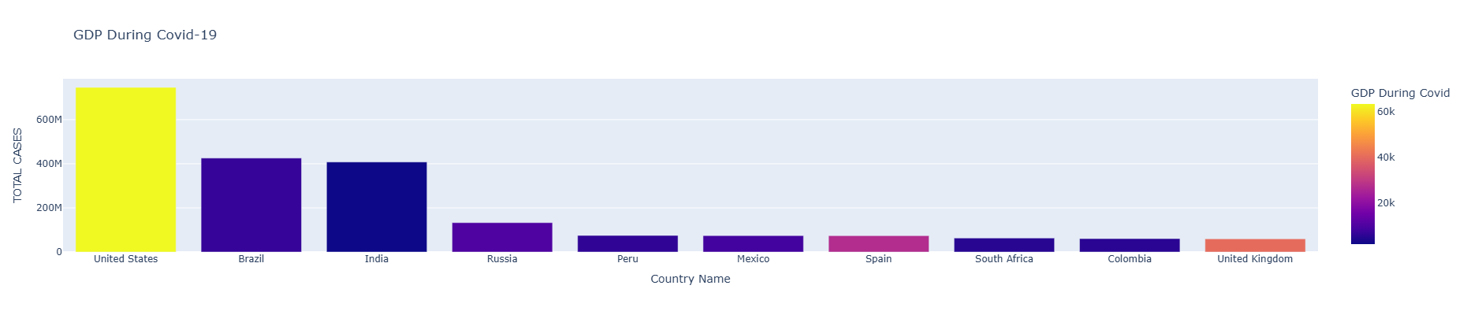

**Analysis -**

* **Total Cases:** The height of each bar shows the number of COVID-19 cases in that country.
* **Stringency Index:** The color of each bar shows how strict the country's COVID-19 restrictions were. Yellow is very strict, purple is less strict.
* **United States:** Had the most cases and was very strict.
* **Brazil and India:** Also had high cases and were fairly strict.
* **Other countries:** Had fewer cases and were less strict.

**Pie chart of percentage of total cases and deaths –**

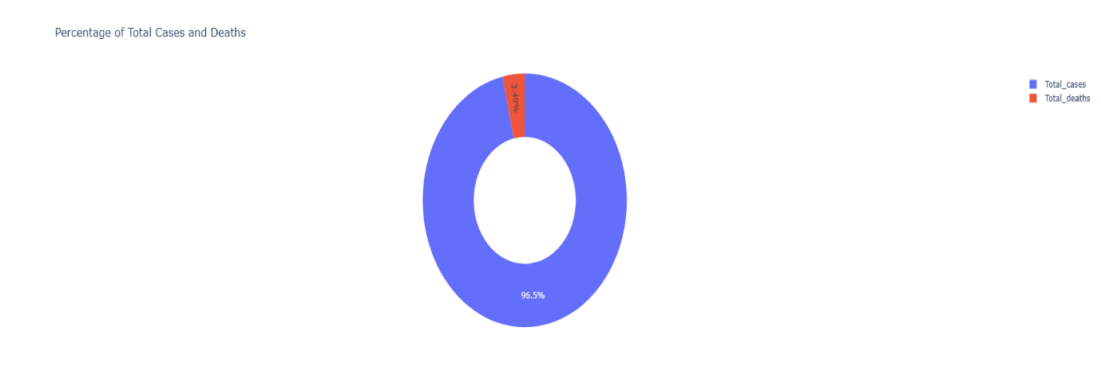

**Analysis –**

This chart shows the proportion of COVID-19 cases and deaths compared to the total number of cases.

* Majority of Cases: The vast majority (96.57%) of the total COVID-19 cases resulted in recovery or are still active cases.
* Smaller Proportion of Deaths: Only a small fraction (3.43%) of the total cases led to deaths.

**GDP per Capita Before and During COVID-19 :**

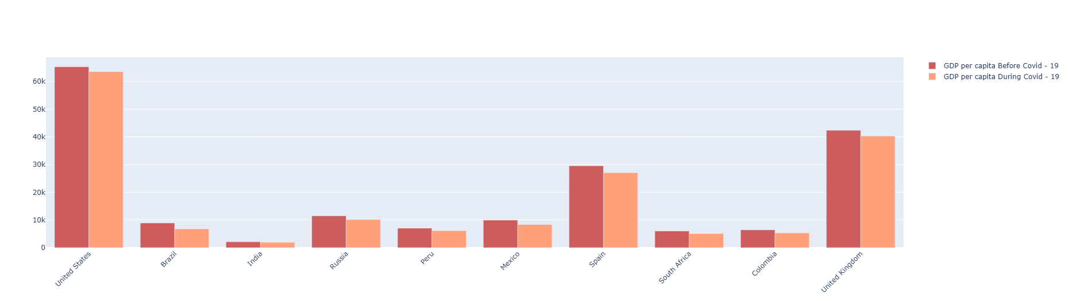

**Analysis :**

* **GDP per Capita:** The height of each bar shows the average income per person in each country.
* **Before vs. During COVID-19:** The graph shows two bars for each country: one for the GDP per capita before the pandemic, and one for the GDP per capita during the pandemic.
* **United States:** Had a high GDP per capita before the pandemic, which decreased slightly during the pandemic.
* **Brazil, India, and Russia:** Had lower GDP per capita before the pandemic, which decreased significantly during the pandemic.
* **United Kingdom, South Africa, Colombia, and Mexico:** Also saw a decrease in GDP per capita during the pandemic.